Wrinkle in Time Journal

Name _______________________

Chapter 1
Journal Entry
Fill out this diary entry from Meg’s perspective. Make sure you include the events that happened along with her feelings.

Draw a picture of Mrs. Whatsit in the space provided.

Chapter 2
Describe Mrs. Who, and then draw a picture of her in the space provided.

Chapter 3
Meg’s home and Calvin’s home are very different. Use this Venn diagram to compare the two homes.

MEG BOTH CALVIN
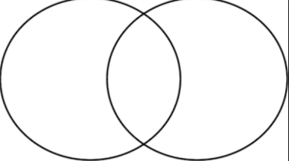

Chapter 4
Fill out this diary entry from Meg’s perspective. Make sure you include the events that happened along with her feelings.

Chapter 5
Explain what a tesseract is. Use an illustration to explain it.
Chapter 6
Describe the Happy Medium, and then draw a picture of her in the space provided.

Use the Venn diagram to compare Camazotz to our country.

Camazotz both USA
Chapter 7
Make a prediction about:
Charles
Meg
Calvin

Chapter 8
Describe the IT, and then draw a picture of IT in the space provided.

Chapter 9
Fill out this diary entry from Meg’s perspective. Make sure you include the events that happened along with her feelings.

Chapter 10
Fill out this diary entry from Meg’s perspective. Make sure you include the events that happened along with her feelings.

Chapter 11
Who is Aunt Beast and what does she do for Meg? Why does Meg have trouble describing things to her?

Why did the author include Aunt Beast in the story?

Chapter 12
Why was Meg chosen to go get Charles ?

What was the key to Meg saving Charles?

The main theme of this book is that love can triumph over evil. Give examples of this theme from the book.

