Name ___________________________
Chapters 1-2
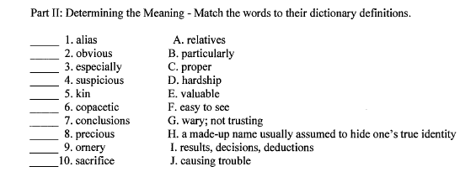

Chapters 3-5
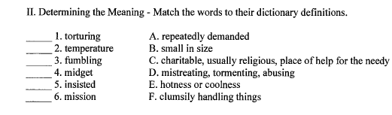
Chapters 6-7
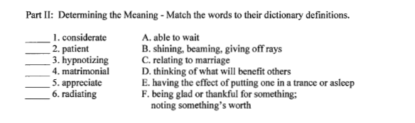
Chapter 8
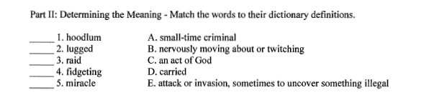
Chapters 9-10
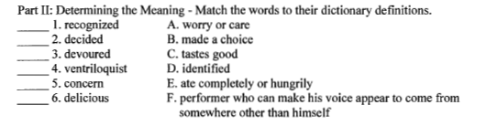

Chapter 11

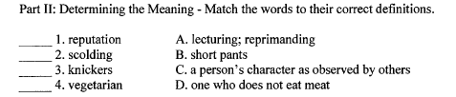

Chapters 12-19

