The Lady, or the Tiger?
About the Author
.......Frank R. Stockton was born in Philadelphia in 1834. He was one of nineteen children. When Frank emerged from a mischievous boyhood, he began to study engraving on wood. Even then he wrote fairy stories, and he contributed to some of the New York papers. In 1860, he married Miss Marion Tuttle of Virginia and soon after came to Nutley to live. About this time he took a position on Hearth and Home, and in 1873 became associate editor of St. Nicholas. "Rudder Grange" was at first a story which he wrote for Scribner's, and it was received with enthusiasm. Then followed years of writing unique stories, his most famous of which are in the form of fairytales, ghost stories, or romances, but in all of them his humor has an edge like a knife. When “The Lady, or the Tiger?” first appeared in Century Magazine in 1882, it caused excitement all over the country. Hundreds of people wrote letters to the magazine or to their newspapers about it. Many letters demanded an answer to the question that the story asks. Others asked if the story was really about government, psychology, the battle of the sexes, or something else. Wisely, Stockton never answered any of the letters. The story remains as fresh today as it was then. Frank Stockton died in 1902.
Anticipation Guide
Put an “X” in the space to indicate whether or not you agree or disagree with the corresponding statement.
Statement(s) | Agree | Disagree
It is possible for two people to know and understand each other completely.

I would trust my life to a lover or close friend.

Jealousy is a stronger emotion than love.

I wouldn’t mind an arranged marriage if my spouse was hot.

The death penalty is a fair way to convict criminals.

Chance and luck are more important than rules and laws.

Read the Lady or the Tiger before answering these questions.
The Lady, or the Tiger? Discussion Questions
- Some stories don’t follow a nice plot diagram. This one ends at the climax. How did you feel when the story ended without its problem being solved?
- Since the king loved his daughter dearly, why do you think he threw her lover in prison?
- Do you think the king’s system of justice is fair? Why or why not?
- “Which came out of the opened door-the lady, or the tiger?” What do you think? Did the princess send her lover to the lady or the tiger? Why?
- The end of “The Lady, or the Tiger?” is about the princess’s decision: whether to send her lover to the lady or to the tiger. But doesn’t the lover, too, have a decision to make? With a movement of her hand, the princess has told him to open the door on the right. This leads us to the final question. Remember, the lover knows that the princess knows which door hides the lady, and which door hides the tiger. How well does the lover know the princess? Will he open the door she has chosen? Or, believing it hides the tiger, will he open the other one? Why, finally, did he open the door on the right?
- Do you think people are less barbaric now than they were hundreds of years ago? In what ways? Are they more barbaric? In what ways? Are they exactly the same? Give specific examples to help others understand your thoughts.

Quiz on The Lady or The Tiger? Name _______________Class______No______
1. There are two doors. Behind one door, there's a lady. Behind the other door, there's ______.
a: a tiger b: another lady c: a king d: a criminal
2. In this justice system, the innocence or guilt of the suspect is _________________ .
a: judged according to the evidence b: left to chance
c: ruled on by the king d: decided by a contest
3. In the story, a princess falls in love with a _____________________ .
a: commoner b: criminal c: married man d: prince
4. The princess helps the suspect by ____________________________ .
a: telling him which door conceals the tiger b: gesturing towards the right door
c: convincing her father to let him go d: allowing him to marry the lady
5. The reader of the story ______________________________ .
a: feels sympathy for the princess b: wants the tiger to kill the commoner
c: doesn't understand why the princess is jealous d: doesn't know the ending of the story
6. If the door opens and it is the lady, it is a happy ending for the _______________ .
a: king b: suspect c: tiger d: princess
7. If this court had a third door and the suspect opened it, the result would probably be
a: bad b: good
c: neither good nor bad d: result in the death of the suspect
8. The princess doesn't want the commoner to be eaten by the tiger, but she also hates the idea of ___________________________ .
a: the commoner marrying the lady b: saving the commoner's life
c: pleasing her father, the king d: giving up her jealous rage
9. In this kingdom, a commoner is ____________________________ .
a: a criminal b: a person without royal blood
c: a person who works on a farm d: a person who is not intelligent
10. The princess will be unhappy if the commoner chooses _____________ .
a: the right door b: the left door c: either door d: the middle door
11. The princess is ____________________________ .
a: the lady's best friend b: the same person as the lady
c: jealous of the lady d: certain the tiger won't hurt the commoner
12. What is the main conflict in "The Lady or the Tiger"?
a: person vs. person b: person vs. self c: individual vs. society d: person vs. nature
13. Which of the following character is a round character?
a: the princess b: the young man c: the tiger d: the king
14. The confusing nature of love and the absence of free will are examples of what literary term?
a:conflict b: plot c: rising action d: theme
15. Of the three elements of suspense, which one is prominent in the story?
a: pacing b: foreshadowing c: dangerous action d: explosions
16. The setting of the story
a:is ancient Rome b: does not matter c: is not specific d: is at the circus
17. It is most likely that _______________________
a: the young man is killed by a tiger. b: the young man is wed to the princess
c: the young man is wed to the girl behind the door. d: only the princess truly knows.
The Lady or The Tiger Name__________Class_________No______
Complete the plot diagram of the story

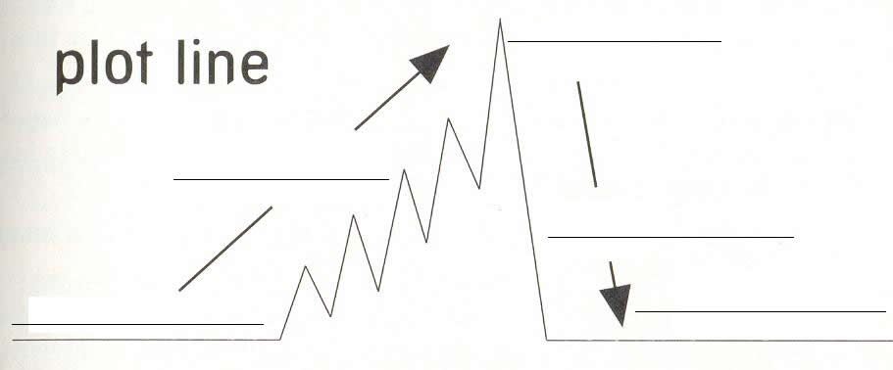

Write a short summary of the story of no more than 100 words
____________________________________________________________________________________________________________________________________________________________________________________________________________________________________________________________________________________________________________________________________________________________________
_________________________________________________________________________________________
Read the story again and write down the words the writer used to describe the characters
The king

The princess

The young man

The audience

Which of the characters is described in more detail? ____________________________________________

Debate: How will the story end? What will come out of the door? The lady or the tiger?
- Take your side.
- Explain. Give at least three reasons why you think so.
- List all the reasons you can think of and organize them.
- Think of what the opposite side will say, and try to pose questions to challenge them.
Your group will give a presentation at the end of the discussion.
Group leader
Time controller
Idea contributor
Questions for the opposition
Speaker

Overall performance

Your opinion: Which side is more convincing? Why?
___________________________________________________________________________________________________________________________________________________________________________________________________________________________________________________________________________

News Report
Suppose that you are a reporter and are assigned to write an article about the outcome of the trial the next day. Think of a good title for the article. (Remember: it should be catchy)

Then, in groups, write your news article. It should have three paragraphs.
1st paragraph: a brief account of what happened in the arena.
2nd paragraph: a more detailed account of how the young man chose the door and what happened when he opened it. (e.g.: how the lion jumped at the man, the facial expression of the man at seeing the beautiful lady out of the door, how the princess felt when she witnessed the young man in the lion’s mouth/ the lady’s arm, or how the audience felt or thought.)
3rd paragraph: explain the origin of the trial, why the king set up such a system, how well it worked, and some past trials that are really memorable.

Assignment
Can you think of a difficult decision you had to make? What was it? How did it trouble you? What decision di you make in the end? Write a paragraph about it.
**If you have never faced such a difficult situation, think of someone who did, or the story from a book, movie and others. If should be a very hard and important decision, like life-or-death, leave-or-stay. **
________________________________________________________________________________________________________________________________________________________________________________________________________________________________________________________________________________________________________________________________________________________________________________________________________________________________________________________________________________________________________________________________________________________________________________________________________________________________________________________________________________________________________________________________________

