SYMBOLs in LITERATURE

A symbol is something concrete that stands for something abstract.

Concrete = 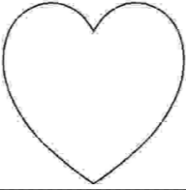 Abstract = love

Concrete = 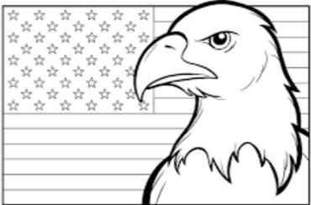 Abstract= freedom

A symbol may be a person, place, thing, or action. It may represent an idea, belief, feeling
or attitude. A symbol keeps its own meaning while also standing for something else.

CONSIDERING COMMON SYMBOLS:
Some symbols become well know in a culture. Match the following common symbols with their meanings.

1. a maple leaf a. United States

2. Uncle Sam b. national pride

3. a dove c. poison

4. a red rose d. luck

5. a skull and crossbones e. youth

6. springtime f. life

7. winter g. love

8. a path h. old age

9. a horseshoe i. peace

10. a nation’s flag j. Canada

SYMBOLs in A CHRISTMAS CAROL
BY CHARLES DICKENS

Scrooge the greed of humanity
Jacob Marley Scrooge’s conscience
The chains the acts of life that come back to “haunt “
The Ghost of Christmas Past how experiences make us who we are
The Ghost of Christmas Present opportunities to care for those around us
The Ghost of Christmas Yet to Come fear of the future
Ignorance and Want man’s children-the plight of the poor-
Fred current family obligations
Belle love and chances not taken
Fezzywig the power of employment and goodwill
Bob Crachit the plight of the working class
Tiny Tim the trust, piety, and innocence of the poor, weak, ill
Cold, foggy weather Scrooge’s cold heart
The Counting House the current lust and greed of society
The Crachit Home the place where Scrooge realizes how his selfishness
has affected others

Scrooge’s Nephew’s home A place where everyone is cheerful even though they are poor. They make fun of Scrooge.

THEME:
The Central theme is that money does not make happiness, and that those that have it should give to the less fortunate.
NARRATOR:
The narrator in the Muppet Christmas Carol is an omniscient narrator. An omniscient narrator is the person in the story who is aware of everything going on within the story. In the movie, Gonzo identifies himself as the omniscient narrator.
FIGURATIVE LANGUAGE:
Dickens used similes and metaphors to make his writing classic. Two famous examples of similes are:
“Marley was dead. As dead as a doornail.”
and
“Scrooge was as solitary as a clam in a shell.”

