Name ____________________
Score _____________________
October 28, 1886: The Dedication of the Statue of Liberty http://www.history.com/topics/statue-of-liberty

- The Statue of Liberty was a gift of friendship from the people of France to the people of the United States. Originally known as “Liberty Enlightening the World,” the statue was planned by the French historian Edouard de Laboulaye to commemorate the Franco-American alliance during the American Revolution.

- In 1876, French sculptor Frederic-Auguste Bartholdi was commissioned to build the 151-foot statue in the form of a woman with an uplifted arm holding a torch. Its framework of gigantic steel supports was designed by Eugene-Emmanuel Viollet-le-Duc and Alexandre-Gustave Eiffel who was famous for his design of the Eiffel Tower in Paris.

- In February 1877, Congress approved the use of a site on New York Bedloe’s Island, which was suggested by Bartholdi. Even though the statue was a gift from the government of France, New York City had been unable to raise $250,000 ($6,300,000 in today’s money) for a granite base for the statue. A group called the American Committee of the Statue of Liberty was given the task of raising the money, but they fell short by more than a third.

- New York Governor Grover Cleveland (before he became president) rejected the use of city funds to pay for the platform for “Lady Liberty,” and Congress could not agree on a funding package. So Baltimore, Boston, San Francisco and Philadelphia offered to pay for the base in return for the statue's relocation to their city. Yet, New York City was determined to keep the statue.

- It seemed as though New York had run out of options when in March of 1885, newspaper owner Joseph Pulitzer decided to launch a fundraising campaign in his newspaper The New York World. Pulitzer headed an energetic fund drive, promising to print the name of each donor in his paper, no matter how small the donation. Pulitzer’s plan worked, and millions of people around the country began donating whatever they could. Schoolchildren across America donated pennies. A kindergarten class in Iowa sent $1.35 to Pulitzer’s fund drive. Finally, all the money had been raised.

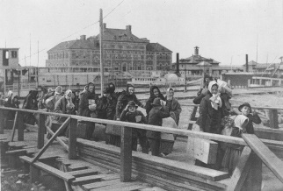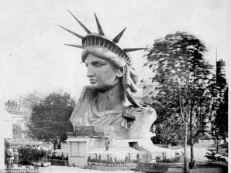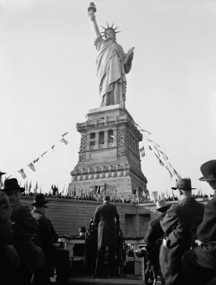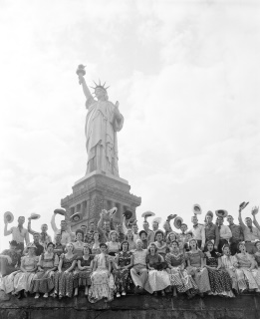

- In 1884, the statue was completed in France, and in June 1885, “Lady Liberty’s” copper sheets were reassembled on the American platform in New York Harbor. The last rivet of the monument was fitted on October 28, 1886, during a dedication led by now President Cleveland. The event was attended by numerous French and American dignitaries.

- In 1892, Ellis Island, right next to Bedloe’s Island, opened as the main entry station for immigrants to the United States, and for the next 32 years more than 12 million immigrants were welcomed into New York harbor by the sight of “Lady Liberty.” In 1924, the Statue of Liberty was made a national monument, and in 1956 Bedloe’s Island was renamed Liberty Island.

- On the pedestal was inscribed “The New Colossus,” a sonnet by American poet Emma Lazarus that welcomed immigrants to the United States with the declaration:

Give me your tired, your poor,
Your huddled masses yearning to breathe free,
The wretched refuse of your teeming shore.
Send these, the homeless, tempest-tossed to me.
I lift my lamp beside the golden door.

Vocabulary: Use context clues to choose the better synonym.
- commemorate | ignore | honor
- alliance | union, partnership | separation, split
- commissioned | given job | found
- rejected | allowed | disallowed
- options | choices | groups
- numerous | few | many
- yearning | hoping, longing | short, minus
- wretched | miserable | brave
- refuse | trash | unwanted
- tempest | capture | hard times
- immigrants | refugees, aliens | citizens

Word analysis: Use your decoding skills to determine the meaning of each word.
word | prefix | root | suffix | meaning
- relocation | re | locate | tion
- reassembled | re | assemble | ed

Summarize: Make a timeline of the construction of the Statue of Liberty from beginning to dedication.
- 1876
- 1877
- 1885
- (March)
- 1885
- (June)
- 1886

- Why did Joseph Pulitzer decide to use his newspaper to raise money for the base of the statue? a) Pulitzer wanted to promote his newspaper b) Pulitzer wanted the statue to stay in New York City c) Governor Cleveland asked him to do it.

Figurative Language: “Lady Liberty “is not just a statue she is a symbol. Describe what she symbolizes in at least two sentences. What did she represent to the immigrants coming in to New York Harbor?

Put it together: Why did the builders include “The New Colossus” on the platform?

Interpretation: In at least three sentences, explain what “The New Colossus” poem means?

On a separate piece of paper:
We often take our freedom for granted. Think over the information you have learned about the Russian Pogroms and the Chinese Cultural Revolution. Explain why the Statue of Liberty is such an important symbol to immigrants, and why freedom is so important. Use one specific example from the Russian Pogrom and one from the Chinese Cultural Revolution to explain why immigrants might want to come to America. Then explain why freedom is so important to you.

