BEAVER

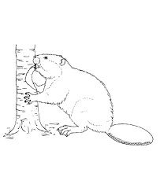

|  |
| --- |
|  |
|  |
|  |
|  |
|  |
|  |
|  |
|  |
|  |
|  |

Wigwam

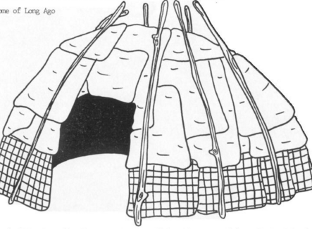

|  |
| --- |
|  |
|  |
|  |
|  |
|  |
|  |
|  |
|  |
|  |
|  |

Beaver Dam

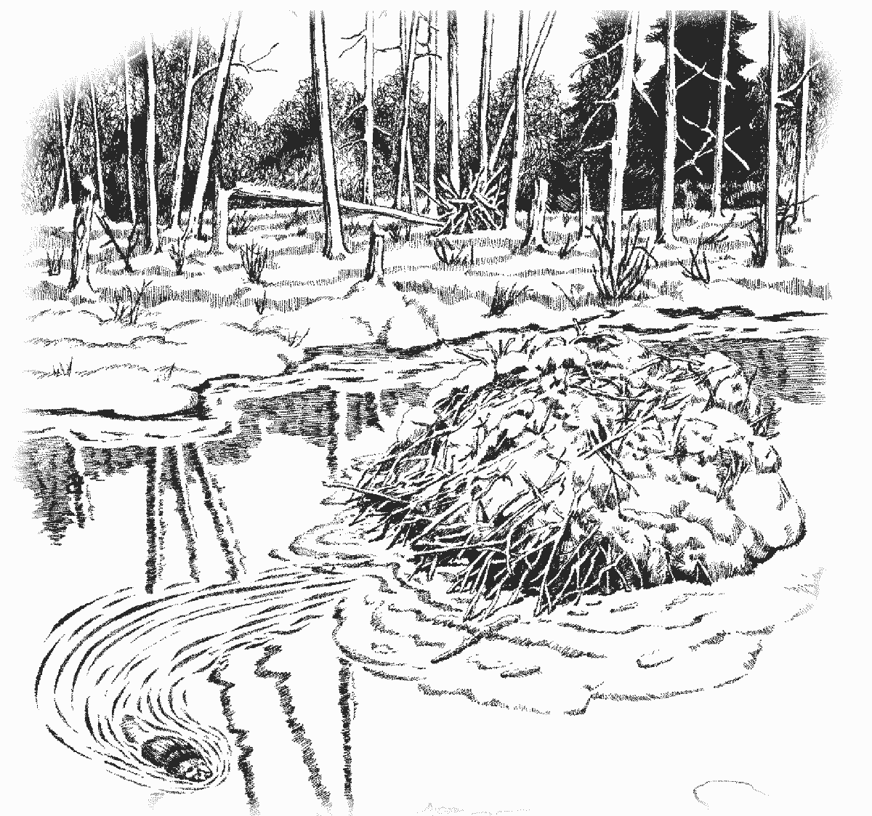

|  |
| --- |
|  |
|  |
|  |
|  |
|  |
|  |
|  |
|  |
|  |

Bear

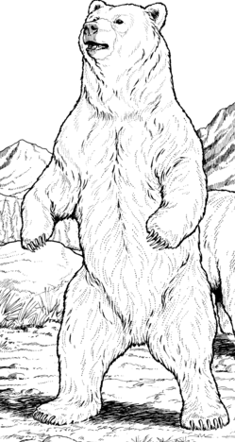

|  |
| --- |
|  |
|  |
|  |
|  |
|  |
|  |
|  |
|  |
|  |

Attean’s Dog

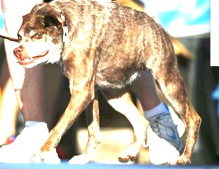

|  |
| --- |
|  |
|  |
|  |
|  |
|  |
|  |
|  |
|  |
|  |

Robinson Crusoe

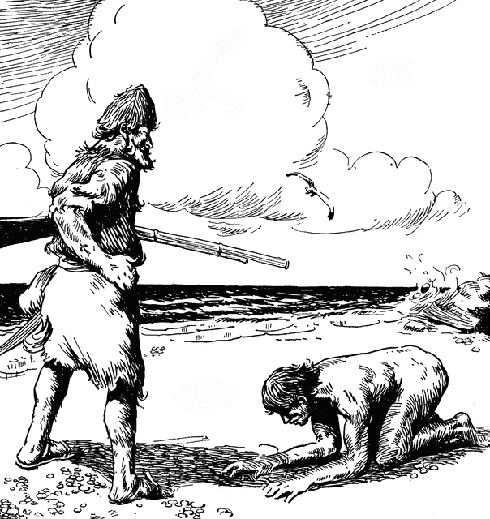

|  |
| --- |
|  |
|  |
|  |
|  |
|  |
|  |
|  |
|  |
|  |

The Cabin

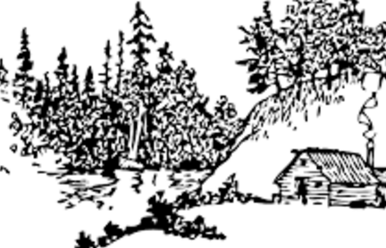

|  |
| --- |
|  |
|  |
|  |
|  |
|  |
|  |
|  |
|  |
|  |

The Bow

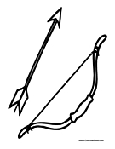

|  |
| --- |
|  |
|  |
|  |
|  |
|  |
|  |
|  |
|  |
|  |

Matt’s Gun

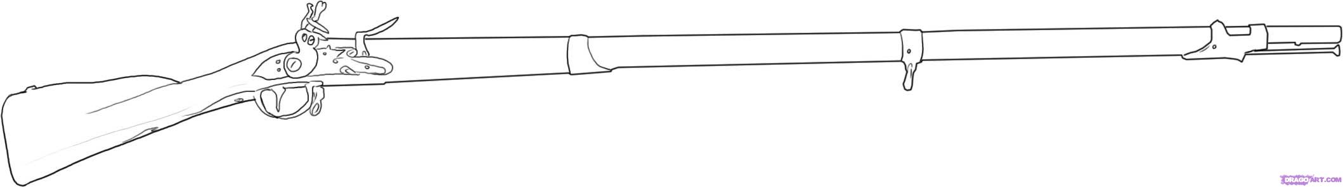

|  |
| --- |
|  |
|  |
|  |
|  |
|  |
|  |
|  |
|  |
|  |
|  |
|  |
|  |

Matt’s Watch



  
  
  
  
  
  
  
  
  
  

  
  
  
  
  
  
  
  
  
  
  
  