Name ___________________________________

Worksheet

1. A B C D

2.
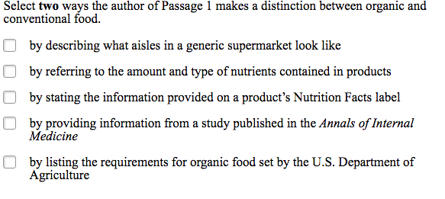
3. A B C D

4. Part A
A B C D

Part B
A B C D

5. Part A
A B C D

