Ohio Test “Beauty and the Beast” Name ____________________________

Question 1

PART A) A B C D

PART B: SELECT THE PHRASE THAT SUPPORTS THE MEANING SELECTED IN PART A

Up and down the paths and avenues poor Beauty
for no one answered and not a trace of him could she find
until at last, quite tired, she stopped for a minute’s rest
and saw that she was standing opposite the shady path she had seen in her dream

2. Write the first two words of the two quotations you choose.

3. A B C D

4. A B C D

5. A B C D

6. A B C D

7. PART A A B C D

7. PART B A B C D

PASSAGE 2: JOHN PHILIP SOUSA
8. A B C D
Question 9
Part A A B C D
Part B A B C D

10. A B C D
11. Select 1 sentence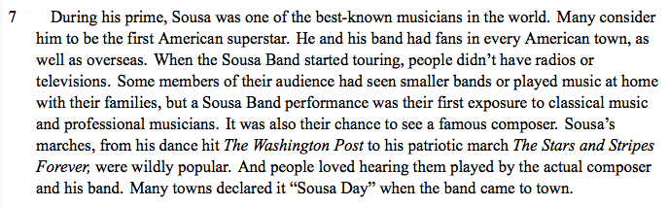
Question 12
PART A A B C D
Part B A B C D

13. A B C D
14. A B C D
15. A B C D
16 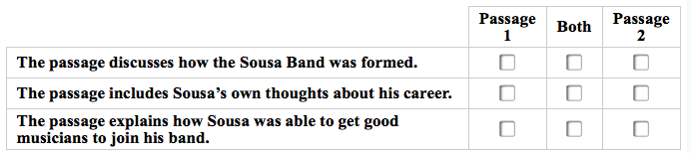
Name _________________________________

