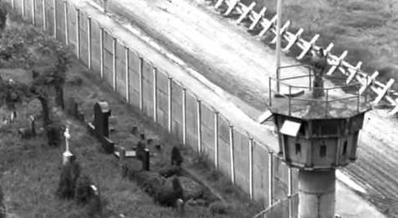
Journal:: A Night Divided

Make a Google doc, and label it
- your name
- AND A Night Divided
- I will make a Google Classroom for each 10 chapters, so you can submit your responses.

Chapters 1-10: For each entry write about how the quote relates to the chapter. Cut and paste the quote to your document, then respond to the prompt.

1. When I want the west to scream, I squeeze on Berlin.
--- Nikita Khrushchev, Soviet Union premier, 1958-1964

2. You are your only border --- throw yourself over it!
Hafis, Persian poet, ca. 1325-1389

3. It's often safer to be in chains than to be free.
--- Franz Kafka, German author

4. The eye looks, but it is the mind that sees.
--- German Proverb

5. The Germans and I no longer speak the same language.
--- Marlene Dietrich, German actress 1960

6. The Wall will be standing in fifty and even in one hundred years if the reasons for it are not removed.
Erich Honecker, first secretary of East Germany, 1971-1989

7. There are no dangerous thoughts; thinking itself is dangerous.
--- Hannah Arendt, German political theorist

8. Fear . . . was the most powerful weapon possessed by the Stasi.
David Cook, British author

9. The penalties for being an accessory to the attempt to flee the GDR were greater than the crime of trying to flee itself.
--- Anna Funder, Australian author

10. A thought, even a possibility, can shatter and transform us.
---Friedrich Nietzsche, German philosopher
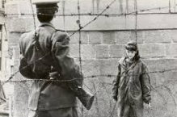
The wall between East and West Berlin was nearly 12 feet high and approximately 27 miles long, with 302 guard towers and 55,000 anti-personnel explosive devices (landmines). To prevent attempts to scale the wall or escape by digging underneath, the wall was reinforced with barbed wire, spikes, metal gratings, bunkers and vehicles made into obstacles.

Chapters 11-20: For each entry write about how the quote relates to the chapter. Cut and paste the quote to your document, then respond to the prompt.

11. Wherever they burn books they will also, in the end, burn human beings.
---Heinrich Heine, German poet

12. Do not rejoice in luck; do not hesitate in the storm.
--- German proverb

13. In the middle of difficulty lies opportunity.
--- Albert Einstein, German physicist and intellectual

14. Who wagers nothing, he wins nothing.
--- German proverb

15. Who shows courage, encourages others.
Adolph Kolping, German priest and social reformer

16. Freedom lies in being bold.
---Robert Frost, American poet

17. Forge the iron while it is hot.
---German proverb

18. Start with what is right rather than what is acceptable.
--- Franz Kafka, German author

19. There are none so blind as those that will not see.
German proverb

20. What is not started today is never finished tomorrow.
---Johann Wolfgang von Goethe, German writer and statesman
Tunnel 57 was a tunnel under the Berlin Wall that on the third and fourth October 1964 was the location of a mass escape by 57 East Berlin citizens. Student and future astronaut Reinhard Furrer was among the West German escape helpers who assisted the East Berliners in escaping.

Commemorative plaque on the house at Strelitzer Strasse 55, in Berlin Mitte

Location marker on the Berlin Wall Memorial, with the Bernauer Strasse in the background
Tunnel 57 was a tunnel under the Berlin Wall that on the third and fourth October 1964 was the location of a mass escape by 57 East Berlin citizens. Student and future astronaut Reinhard Furrer was among the West German escape helpers who assisted the East Berliners in escaping.

Commemorative plaque on the house at Strelitzer Strasse 55, in Berlin Mitte

Location marker on the Berlin Wall Memorial, with the Bernauer Strasse in the background
Tunnel 57 was a tunnel under the Berlin Wall that on the third and fourth October 1964 was the location of a mass escape by 57 East Berlin citizens. Student and future astronaut Reinhard Furrer was among the West German escape helpers who assisted the East Berliners in escaping.

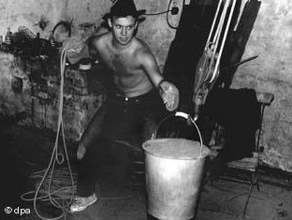

Chapters 21-30: For each entry write about how the quote relates to the chapter. Cut and paste the quote to your document, then respond to the prompt.

21. To begin is easy, to persist is art.
---German proverb

22. As soon as you trust yourself, you will know how to live.

--- Johann Wolfgang von Goethe, German writer and statesman

23. A steady drop will carve the stone.
---German proverb

24. If you live among wolves, you have to act like a wolf.
--- Nikita Khrushchev, Soviet Union premier, 1958-1964

25. Intelligence is not to make no mistakes, but quickly to see how to make them good.
--- Bertolt Brecht, German Playwright

26. One today is better than ten tomorrows.
-- German proverb

27. Forget not the tyranny of this wall, horrid place, nor the love of freedom that made it fall.

---Written on the Berlin Wall after it came down.

28. Shut your mouth, then no mosquito flies into it.
---German proverb

29. Lost goods, lost something; lost honor, lost much; lost courage, lost all.
--- German proverb

30. Caught together, hanged together.
--- German proverb

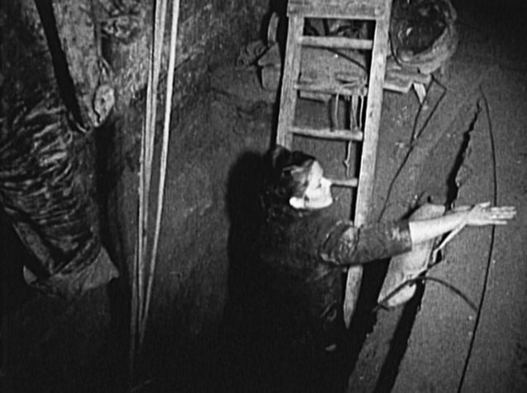
Fleeing East Germany was dangerous. Border guards had orders to shoot any escapees on the spot. Researchers estimate that 136 people died trying to cross the wall and about 750 perished along the entire 856 miles of the border separating East and West Germany. It is not clear how many were killed trying to flee through the tunnel system.

Chapters 31-40: For each entry write about how the quote relates to the chapter. Cut and paste the quote to your document, then respond to the prompt.

31. An appeal to fear never finds an echo in German hearts.
--- Otto von Bismarck, creator of the German Empire

32. A nation that is afraid to let its people judge the truth and falsehood in an open market is a nation that is afraid of its people.
--- John F. Kennedy, US President, 1962

33. God preserve me from my friends, I can deal with my enemies.
--- German proverb

34. A disaster seldom comes alone.
--- German proverb

35. The only way to deal with an un-free world is to become so absolutely free that your very existence is an act of rebellion.
---Albert Camus, French author

36. I learned that courage was not the absence of fear, but the triumph over it.
--- Nelson Mandela, South African activist

37. He only earns his freedom and his life who takes them every day by storm.

---Johann Wolfgang von Goethe, German writer and statesman

38. Everything that is done in the world is done by hope.
---Martin Luther, German priest

39. I was aware that it could all go horribly wrong.
---Gunter Wetzel successful escape to West Berlin 1979

40. No one knows where the shoe pinches, but he who wears it.
---German proverb

''Security has become so tight that it is virtually only madmen who attempt to cross directly from East to West."

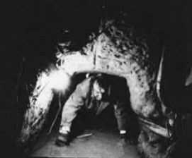

Chapters 41-47: For each entry write about how the quote relates to the chapter. Cut and paste the quote to your document, then respond to the prompt

41. Postponement brings danger.
German proverb

42. Never say there is nothing beautiful in the world anymore. There is always something to make you wonder
--- Albert Schweitzer, German Theologian, physician, and philanthropist

43. There is no such thing as a little freedom. Either you are all free, or you are not free.
--- Walter Cronkite, American journalist, 1965

44. Many kiss the hand they wish to cut off.
--- German proverb

45. They do not have the courage to say it was a wall of disgrace.
--- Helmut Kohl, chancellor of West Germany when the wall came down

46. Freedom is never voluntarily given by the oppressor. It must be demanded by the oppressed.
---Dr. Martin Luther King, Jr., American civil rights activist, 1963

47. All free men, wherever they may live, are citizens of Berlin. I take pride in saying, "Ich bin ein Berliner!"
--- John F. Kennedy, US President, 1963

----------
“General Secretary Gorbachev, if you seek peace, if you seek prosperity for the Soviet Union and Eastern Europe, if you seek liberalization: Come here to this gate! Mr. Gorbachev, open this gate! Mr. Gorbachev, tear down this wall!”

President Ronald Reagan, Brandenburg Gate, 1987

