My Gettysburg Address journal
__________________________________

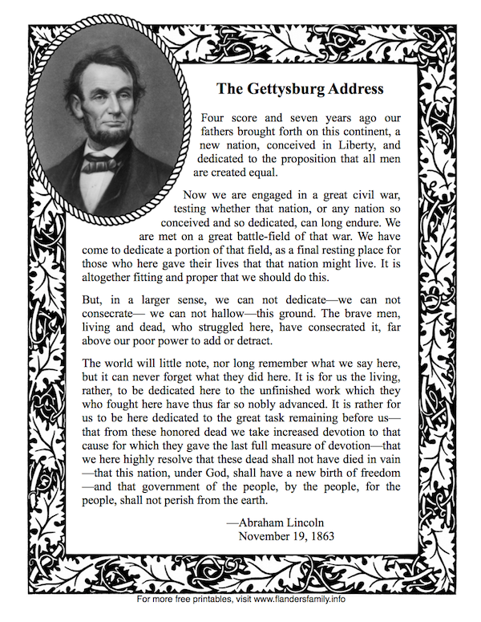

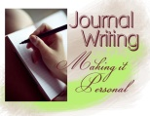Journal Entry One:

After reading Pink and Say by Patricia Polacco, use answer these questions for your journal entry.

- What does “Not bad if it don’t go green.” mean?

- Why did Pinkus help Shelton?

- Who are the Marauders?

- Why do Pinkus and Sheldon need to leave as soon as possible?

- What is Moe Moe Bay like?

- What do you learn about slave life from this story?

- What do you learn about slaves in the army?

- What do you learn about teens in the army?

- How does the author foreshadow that something bad might happen to Pinkus?

- Why is it unusual that Pinkus can read?

- How does Moe Moe Bay comfort Say?

- What happened to Moe Moe Bay?

- What happened to Pinkus at Andersonville Prison?

- What happened to Sheldon Russell Curtis?

Journal Entry Two:

- What is the relationship between history and memory?

- How does perspective affect memory?

- How does memory affect the way a story is told?

- Why did Ms. Polacco write this story?

- Is this story true?

- How could you prove this story is true?
?
Journal Entry Three:

- Was gangrene a problem during the Civil War?

- Were marauders a problem in the Civil War?

- Did slaves join the Union army?

- Was there a Pinkus Aylee in the Union forty-eighth slave unit?

- Were slaves in the army sometimes not allowed to carry guns?

- Did fifteen-year-old boys carry the staff?

- Did boys sometimes have to carry a gun?

- Was there a Sheldon Russell Curtis in the Ohio twenty-fourth?

- Was this an accurate portrayal of slave life?

- Was this a realistic portrayal of life at Andersonville Prison?

Journal Entry Four:

Group members:

Section One: Four score and seven years ago our fathers brought forth on this continent a new nation, conceived in liberty, and dedicated to the proposition that all men are created equal.

Journal Questions:

- What happened four score and seven years ago?
- Is there a reference to slavery here? Explain.
- Where does the quote “all men are created equal” come from?
- Why did Lincoln use this quote?

Section 2: Now we are engaged in a great civil war, testing whether that nation, or any nation so conceived and so dedicated, can long endure. We are met on a great battlefield of that war. We have come to dedicate a portion of that field, as a final resting place for those who here gave their lives that that nation might live. It is altogether fitting and proper that we should do this.
Journal Questions:
5. How did Lincoln present the present problem?
6. What was the test?
7. What is the occasion?
8. What was the mood?
9. What was Lincoln’s purpose in this speech?

Section 3: But, in a larger sense, we cannot dedicate, we cannot consecrate, we cannot hallow this ground. The brave men, living and dead, who struggled here, have consecrated it, far above our poor power to add or detract. The world will little note, nor long remember what we say here, but it can never forget what they did here.
Journal Questions:

10. How did Lincoln honor the dead?
11. How does he express humility?
12. Was Lincoln’s prediction in the bolded sentence come true? Explain.
Section 4: It is for us the living, rather, to be dedicated here to the unfinished work which they who fought here have thus far so nobly advanced. It is rather for us to be here dedicated to the great task remaining before us—that from these honored dead we take increased devotion to that cause for which they gave the last full measure of devotion—that we here highly resolve that these dead shall not have died in vain—that this nation, under God, shall have a new birth of freedom—and that government of the people, by the people, for the people, shall not perish from the earth.
Journal Questions:
13. How does Lincoln challenge his audience?
14. What is the quote in this section? Where does it come from?
15. Why did Lincoln include this quote?
Journal Entry Five:

- Define voice, mood, and tone.
- Explain how Lincoln used these three factors in the Gettysburg Address.

Journal Entry Six:

- Describe the difference between revising and editing.
- Explain why each is important to the final publication.
Journal Entry Seven:
- Describe a day in the life of an African American during the days of Jim Crow.
- Make a list of your feelings about Jim Crow laws. Use descriptive words. Use a thesaurus if you need.

Journal Entry Eight:
- What were two examples of Jim Crow laws that Marian Anderson faced?
- Why do you think so many people showed up to see Marian Anderson's concert at the Lincoln Memorial?

- If you could ask Marian Anderson one question about her life and experiences, what would your question be?

Journal Entry Nine:
- Make a list of words that would describe Rosa Parks.
- Why did she do what she did?
- Did Rosa Parks do the right thing? Explain your answer.

Journal Entry Ten:

- What was it like for Ruby Bridges?
- Describe her courage.

Journal Entry Eleven:
Make a Venn diagram to compare and contrast the content of the “I Have a Dream” speech to the Gettysburg Address.
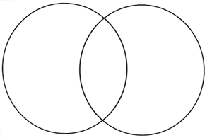

Journal Entry Twelve:
Use this graphic organizer to demonstrate the similarities between the tone, mood, voice and organization of the “I Have a Dream” speech and the Gettysburg Address. Include evidence of collaboration.

 | Gettysburg Address | I Have a Dream
tone
mood
voice
organization
collaboration

