Informational Reading Strategies Name _____________________
Brainstorm: Make a list of everything you have read during the past 24 hours.
(Hint: Not all reading is in books.)

What is Informational Text?
Primary Purpose:
giving information about the _______________- ___________ or _________________
  - Nonfiction:
  - prose writing that is based on___________, real _________, and ________ people, such as

  - __________________ or _______________________
Identify:
Usually specific _______________________________ characteristics
Includes:
- Textbooks (science, social studies, math, health, etc.)

Why?
% of sixth grade reading tasks are expository (informational)
% of standardized tests are expository
Reading for information gives _____________________ to reading.
Your ___________________ in school and life is closely tied to your ability to __________________ expository text.

Why do we need more than vocabulary to read?
1.Bridging gaps:
- making connections drawing from prior knowledge
- inference
- Resolving Ambiguity:
- Use knowledge and context to figure out confusing phrases

So who are “good readers?”
People who _______________ a bit of _______________________, so they
know __________________________ about whatever comes up on a reading test.
How do we gain knowledge?
  - Science Class
  - Social studies class
  - Reading not just fiction
  - Google-ing
  - TV-History and Science programs (even Jeopardy)

Informational Reading Strategies
- Identify Key ideas and details
- Details and _________________
- Relationships between ___________________
- Analyze the craft and structure
- Vocabulary
- Text ___________________________
- Observe and ________________ knowledge and ideas
- Visuals
- Reasons and ___________________
- Integrate information from multiple ___________________
- Take ____________________ when the text is complicated.

Informational Text Categories: Think about genres
Literary nonfiction:
- Combines factual elements with information
- Uses literary devices with informational text structures
- Focuses on text structures
Exposition:
- Straightforward information
- Academic vocabulary crucial to meaning
- Looks like a textbook
Argument/Persuasion
- Text that use arguments and evidence to convince the reader of their position.
Procedural Texts/Documents
- Step by step texts that describe HOW to complete a task
- Technical documents
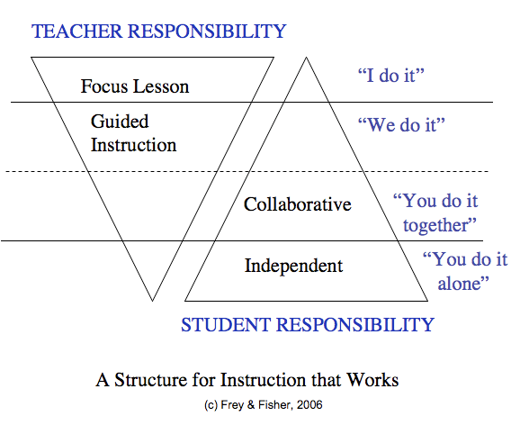
Table of Content Prediction
Observe the book ______________/first _________________
Predict using the table of __________________________ by chapter.
Think about text ___________________________ and _____________________________
and ________________________________ presentation of information.
Reflect on the _______________ _________________ of the text.

Recounting Details
- Retell expository text with _____________________.
- Base writing on _____________ ideas and ____________, not storytelling.
- Utilize text ______________________________ to organize information.
- Read, reread and ______________ ________________ or listen intently.
- Use oral and/or written skills affectively.

Utilizing Text Structure
- Segment text. (Take it apart. Divide it up. Categorize.)
- Keep track of information. (Write it down.)
- See how text is organized:
- Description
- Cause-effect
- Comparison-contrast
- Problem-solution
Webs: Steps:
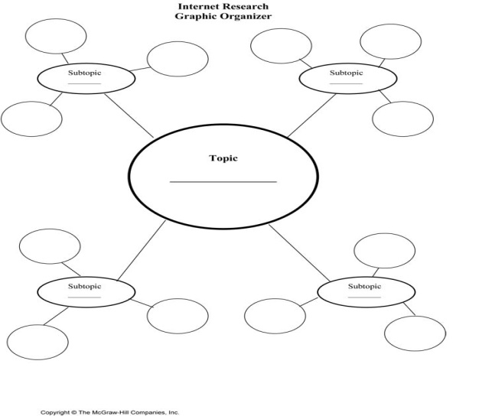
First:
Second:
Third:
Next:
Finally:

