The Hero’s Journey Game
START | Describe the initial setting of the story. | Ordinary  World |  |  | The hero is presented with a problem, challenge, or adventure. | Call to Adventure
 |  |  | Meeting with the Mentor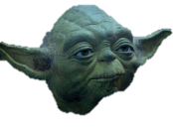 |  | Someone to advise or guide the hero is introduced. |  | Refusal of  the Call
The hero decides to undertake the challenge and agrees to face the consequences. | Outside the hero’s “normal”  world. |  |  |  | A series of other problems come along to test the hero along the way. | Crossing the  Threshold  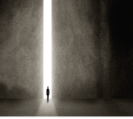
 | 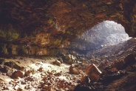 | Approach to the Inmost  Cave | This is the most dangerous place in this other world.
 | The hero confronts his/her fear. The height of the suspense & tension in the story. | O  R  D  E  A  L |  |  | The hero seizes the object of the quest and/or gets something that will lead to a better world. | REWARD  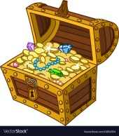
Resurrection | The turning point for the hero to use his new skills |  |  |  | The Road Back | The hero begins the journey back home, or to a new destination.
 |  |  |  |  | The hero returns to the ordinary world or a new world with new knowledge. | Return with the Elixir | Finish

