Name of book _____________________________________________________ level ________

Author ___________________________________________________________ points ______

Describe the main setting and one other important setting in this book. Explain the role of the main setting in the plot.

Determine the protagonist in the story. Explain how the character changes, and what other characters and circumstances caused the change. Support your answer with evidence from the book.

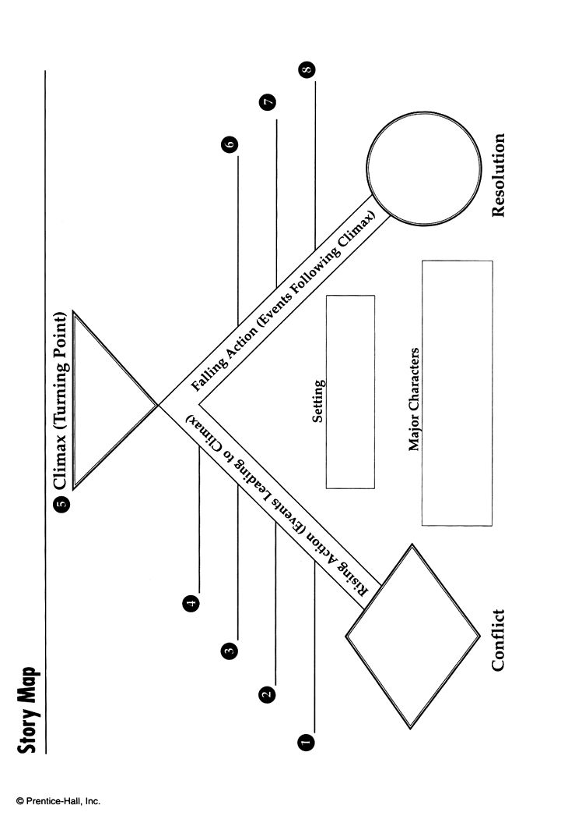
Make a story map of the plot of this novel. Make sure the events are in proper sequence.

