My Gettysburg Address: Name __________________________________

The goal of this writing assignment is to:
  - Research background information
  - Consider audience
  - Improve word choice skills
  - Understand and implement appropriate mood and tone
  - Demonstrate appropriate voice
  - Implement Writer’s craft
  - Improve revising skills
The Gettysburg Address
2 ½ minutes 272 Words
“A few appropriate remarks”
Never to be forgotten

- What made these 272 words great? How did he say everything that needed to be said in less than three minutes? Why are we still talking about it today?

Setting: Where and When ______________________________________ ____________________________
Audience: Who? Diverse? ____________________________________________________________________
Word Choice: Choose wisely. Utilize a thesaurus. (Lincoln used 272 powerful words. 190 of them were single-syllables, only four were four-syllables. He also chose familiar, passionate quotes. Martin Luther King, Jr. used similar strategies in his “I Have a Dream” speech.)

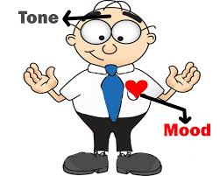
Tone and Mood

Tone: _____________________________________ Mood ___________________________________________

Lincoln’s tone had to reflect the correct mood. His feelings and passion needed to be impressed on his audience. He needed to express sympathy and respect, but most of all his audience needed hope.

Voice: Voice is how you make it your own. (Lincoln established the appropriate mood through his tone, not just through the words he chose, but also with the passion of his presentation. Dr. King used a passionate presentation to connect with his audience and to drive his points into their hearts.)

You’ve considered the audience; you’ve considered the tone and mood, now you must consider:
- How do I feel? What is my passion? How do I express what needs to be said in a way that is uniquely mine?
- Lincoln was intelligent and educated, but he never forgot his humble beginnings.
- His VOICE demonstrated his brilliance, but he also showed his humility.

Writer’s Craft:
Lincoln knew what he wanted to say; the craft was figuring out how to say it best.
- Lincoln divided his speech into three parts:
  - Paragraph one – past history
  - Paragraph two – present situation
  - Paragraph three – future action
  - (Dr. King did this, too.)

- Lincoln chose to quote from the Declaration of Independence. These words were:
- Well know
- Patriotic
- Inclusive of the entire audience
- Appropriate to the slave issue
  - Emotional
  - (Dr. King did this, too.)

- In addition, many people of that day went to church and were familiar with the Authorized Version of the Bible referred to as the King James Version. (Lincoln and King both referred to the Bible.)
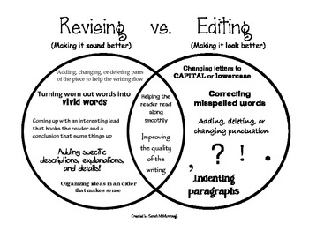
Revising is not the same as editing. Editing is checking for grammatical errors: spelling, capitalization, punctuation, subject verb agreement, etc.

Revising has to do with saying what you want to say in the best possible way using:
- The most powerful, commanding words to make strong points, emotional words for effect, and phrases that connect your audience with your cause.

- The dramatic use of contrast “The world will little note, nor long remember what we say here, but it can never forget what they did here.”

- The flow of sentences that emphasizes the meaning.

- THE ASSIGNMENT

- Choose a topic about which you feel passionately. It must have:
  - A history________________________________________________________________
  - A present problem _____________________________________________________________
  - A solution_______________________________________________________________
- Research your topic for background information.
- Write a speech that is exactly 272 words long and takes approximately 2 ½ minutes to present.
- Consider
  - Your audience _______________________________ ________________________________
  - Word choice________________ ______________ ________________ ______________
  - Mood________________________________________________________________________
  - Tone_________________________________________________________________________
  - Voice ________________________________________________________________________
  - Evaluating your writer’s craft: (Set it up/Revise)
- Use appropriate quotes
  - _____________________________________________________________________________
  - _____________________________________________________________________________
  - _____________________________________________________________________________
- Revise with at least two responsible peers. Document this with initials.
- Edit and proofread. Have a peer verify your word count. (272)
- Practice reading with the voice that expresses your VOICE. (In front of a mirror, record and watch, etc.)
- Memorize it, or learn it well enough that you are not bound to your reading.

Name ________________________________

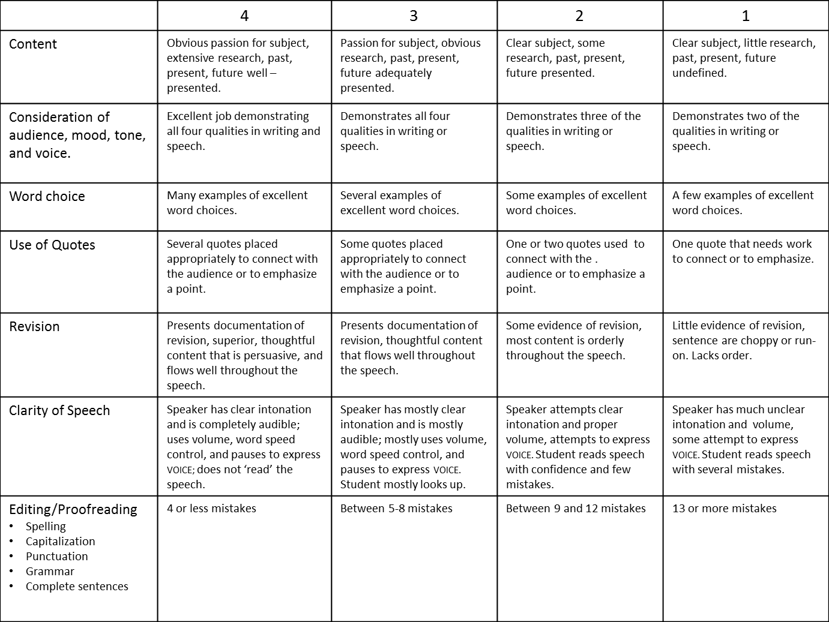

Peer editors: ______________ _________________ ______________________
Word Count: ________ Verified: Your initials:________________ Peer initials: ________________
Final Score: __________________ Final Grade: ___________________

Teacher’s Comments:

