This summer I was chosen as a Summer Scholar for the National Endowment for the Humanities. Sunday, July 6, I headed to Gettysburg for a week of classes, on-sight training, and collaboration with peers from all over the United States including Puerto Rico. The interaction with professors and experts, and sharing with peers was an incredible experience that has renewed my fervor for teaching and honed my instructional skills.
As part of the event, I was required to create a project to use in my classroom. Later in the year, we will engage in this project based on primary documents and my firsthand experiences. I have included some pictures to share with you until that time.

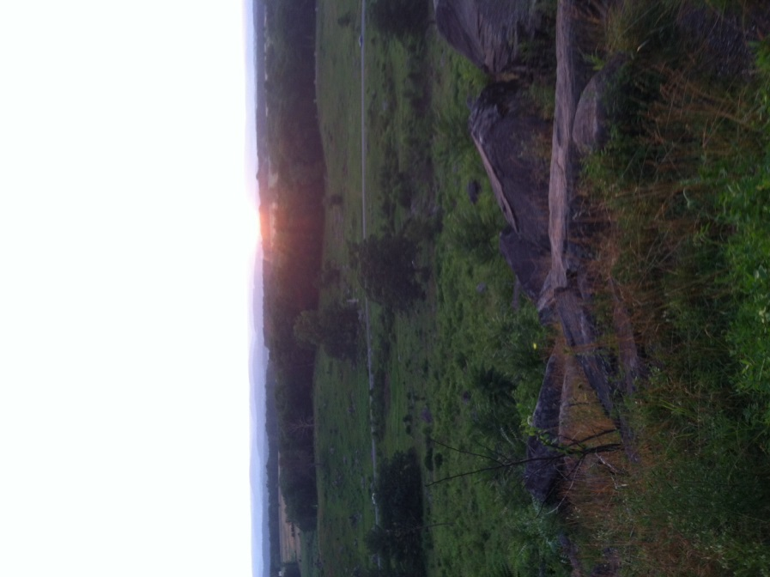
After a day of study of the Battle of Little Round Top, we climbed to the top and surveyed the area at sunset.

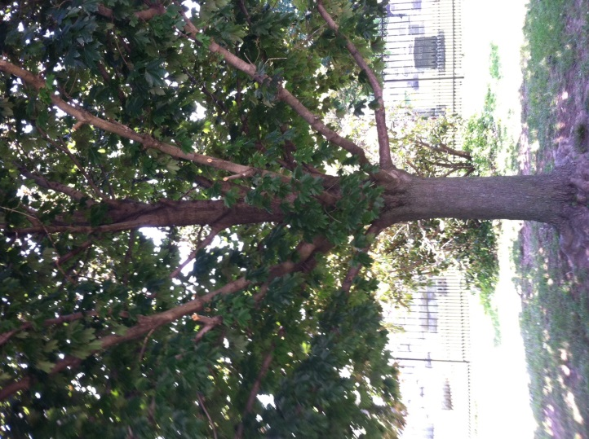
Although years ago the park service marked a different location, after studying original documents, this is the current most accurate location of Lincoln’s presentation of the Gettysburg Address.
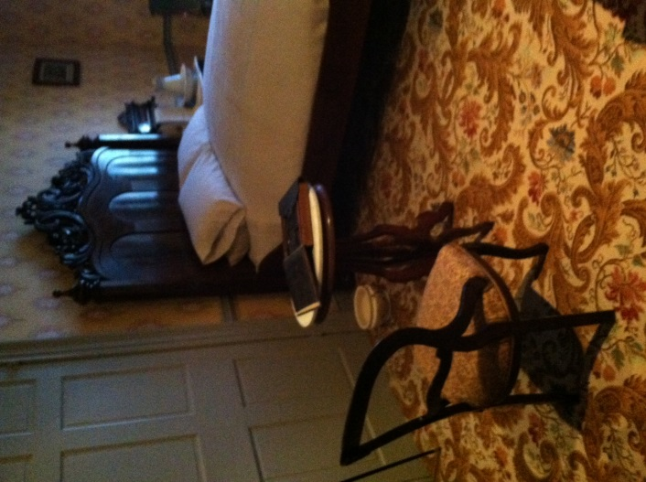
This is the bedroom in which Lincoln stayed the night before he gave the Gettysburg Address.

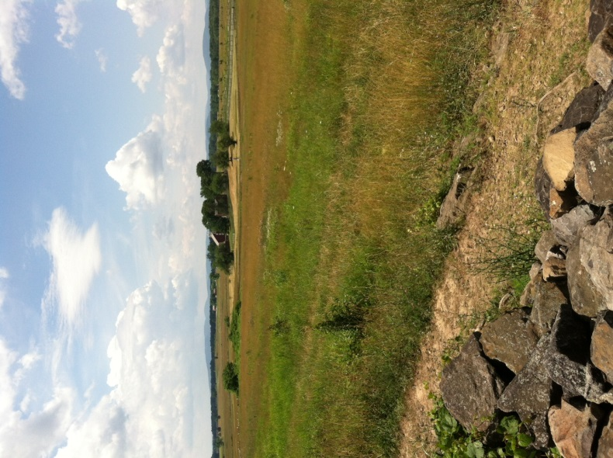
This was the best hands-on experience of the week. Dr. Carol Reardon took us to the site, walked us through the path Pickett’s men would have traveled, and explained the circumstances at each point. This made me realize how important hands-on learning is.

