“What on Earth Are Moon Trees?” Name_______________________________________

Question 8

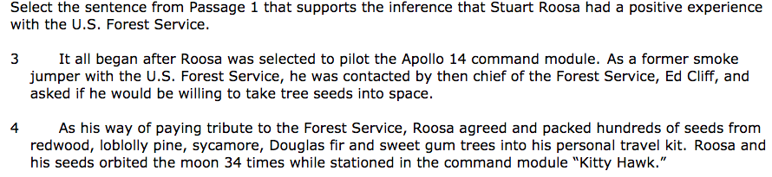

Question 9
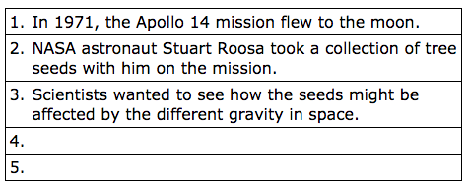

Question 10

Part A A B C D

Part B A B C D

Question 11 A B C D

Question 12 A B C D

Question 13 Part A A B C D

Part B sentence 7 8 9

Question 14 A B C D

Question 15 Type your main ideas:

Question 16 Type the first word of your two choices.

Question 17 Type the first word of each point in the diagram.
